Offered For Sale Two Car Parking Spaces with Advertising Potential Offers Sought in Excess of £25,000

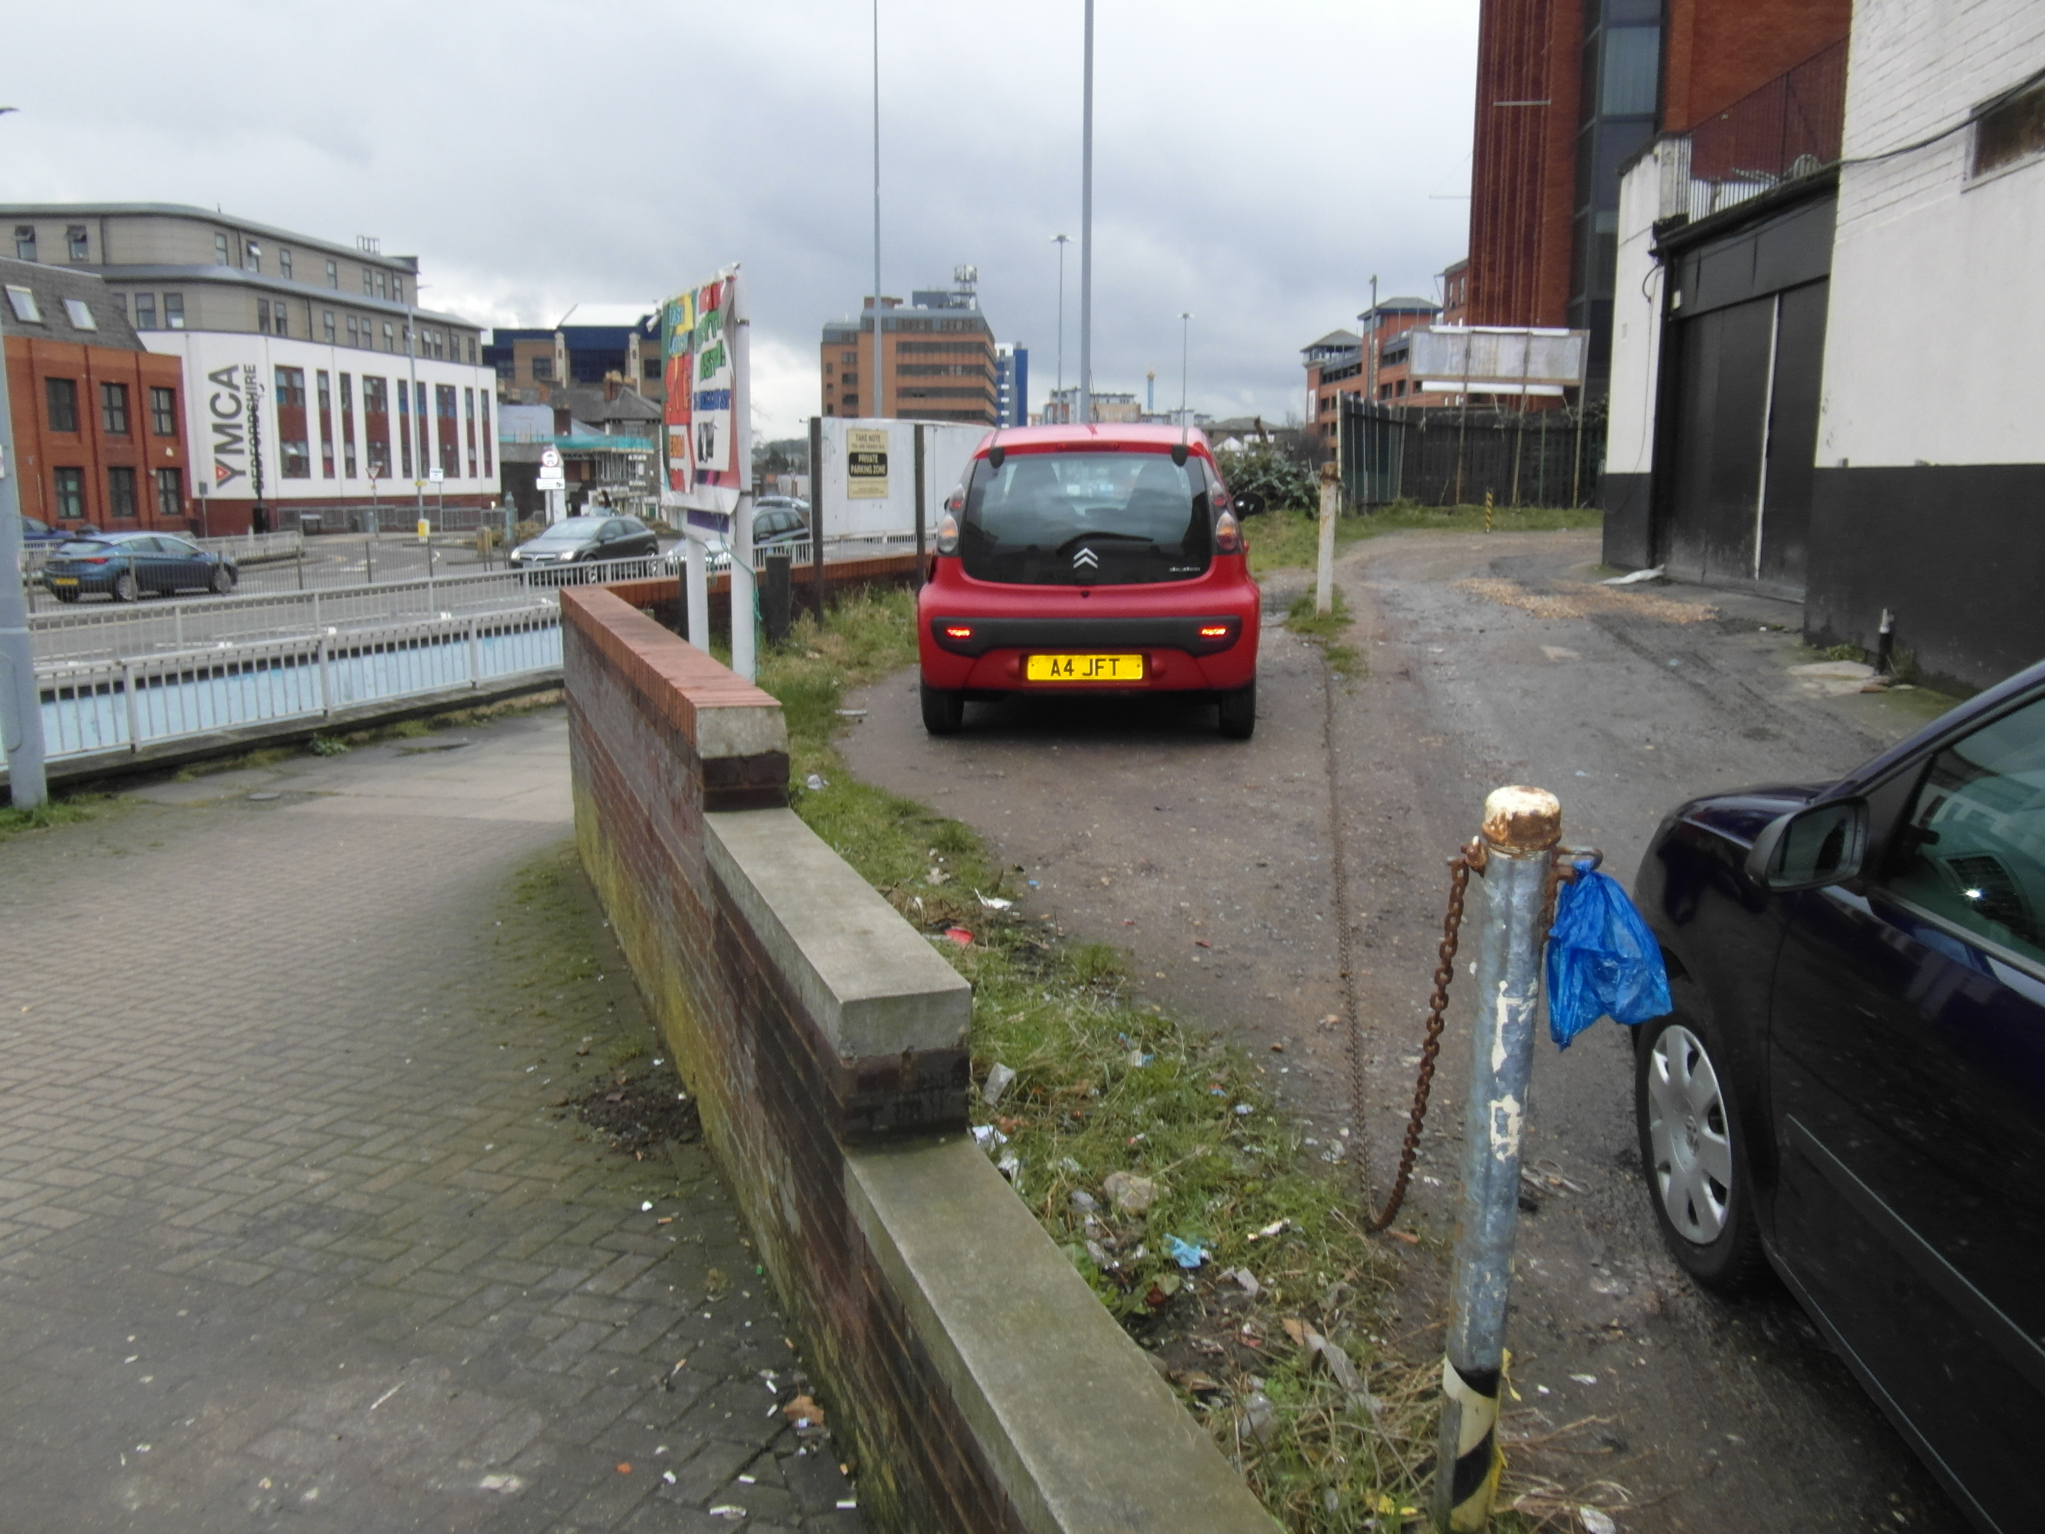 | Prominent town centre location adjacent to Stuart Street
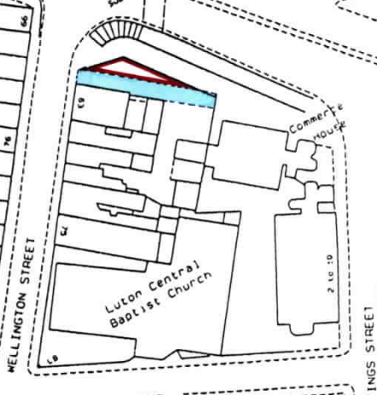 | 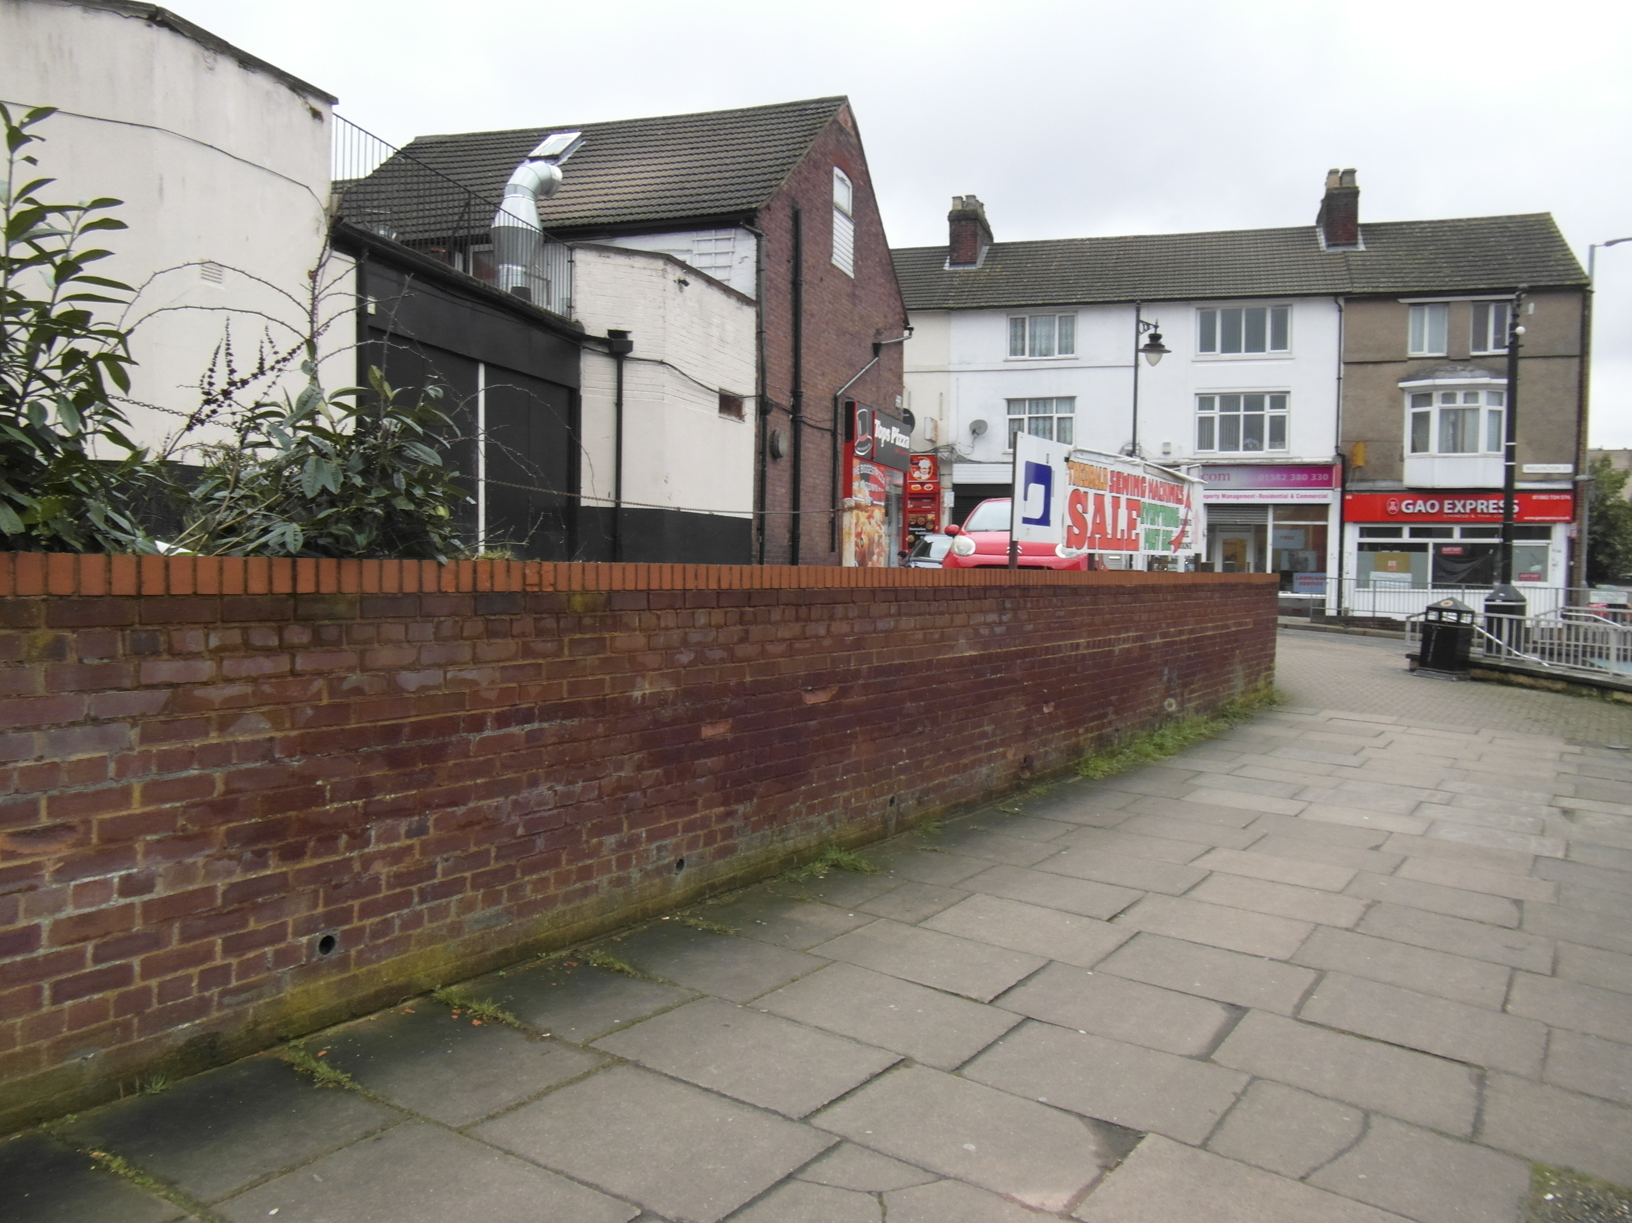

All enquiries to sole agent Peter Hill Chartered Surveyors 01582 724828 / 07973 148576

